Exercise 1: Implementing the Singleton Pattern

Code:

Logger Class:

public class Logger {

    private static Logger instance;

    private Logger(){

        System.out.println("Logger Initialized");

    }

    public static Logger getInstance(){

        if(instance == null){

            instance = new Logger();

        }

        return instance;

    }

}

Test Class:

public class TestSingleton {

    public static void main(String[] args) {

        Logger l1 = Logger.getInstance();

        Logger l2 = Logger.getInstance();

        //Test if both instance are same

        System.out.println(l1 == l2);

    }

}

Output:

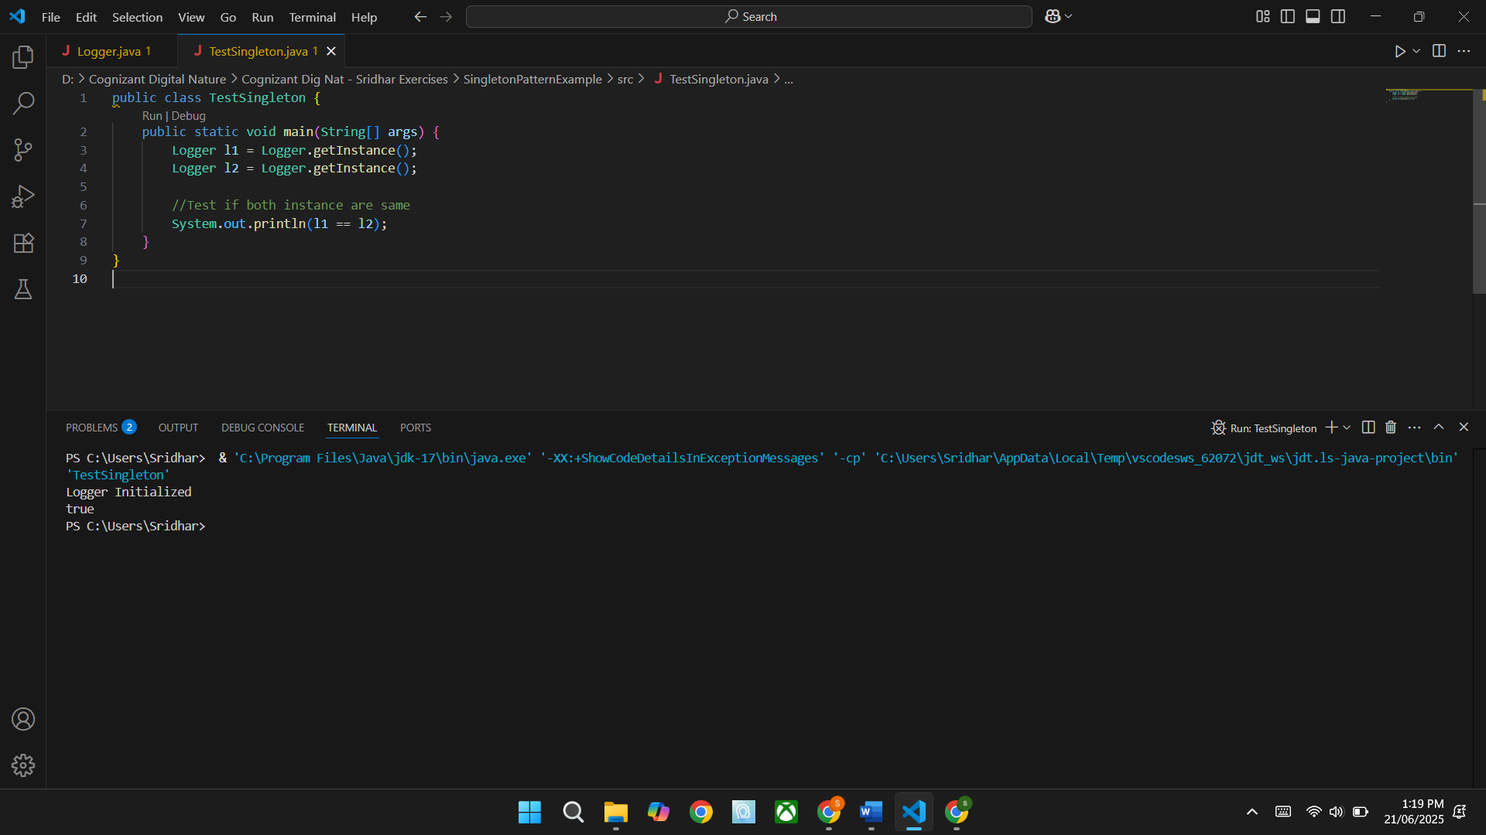

**Exercise 2: Implementing the Factory Method Pattern**

**Document Interface:**

public interface Document {

    void open();

}

**Concrete Document Classes:**

public class WordDocument implements Document {

    @Override

    public void open(){

        System.out.println("Word Document");

    }

}

public class PdfDocument implements Document {

    @Override

    public void open(){

        System.out.println("Pdf Document");

    }

}

public class ExcelDocument implements Document {

    @Override

    public void open(){

        System.out.println("Excel Document");

    }

}

**Factory Method:**

public abstract class DocumentFactory {

    public abstract Document createDocument();

}

Concrete Factory Classes:

public class WordDocumentFactory extends DocumentFactory {

    public Document createDocument(){

        return new WordDocument();

    }

}

public class PdfDocumentFactory extends DocumentFactory{

    public Document createDocument(){

        return new PdfDocument();

    }

}

public class ExcelDocumentFactory extends DocumentFactory{

    public Document createDocument(){

        return new ExcelDocument();

    }

}

**Test Factory:**

public class Test {

   public static void main(String[] args) {

    DocumentFactory word_Factory = new WordDocumentFactory();

    Document word_doc = word_Factory.createDocument();

    word_doc.open();

    DocumentFactory pdf_Factory = new PdfDocumentFactory();

    Document pdf_doc = pdf_Factory.createDocument();

    pdf_doc.open();

    DocumentFactory excel_Factory = new ExcelDocumentFactory();

    Document excel_doc = excel_Factory.createDocument();

    excel_doc.open();

   }

}

**Output:**

